Ideation Phase
Brainstorm & Idea Prioritization Template

Date | 29 January 2026
Team ID | LTVIP2026TMIDS82279
Project Name | Rising Waters: A Machine Learning Approach to Flood Prediction
Maximum Marks | 4 Marks

Step-1: Team Gathering, Collaboration and Select the Problem Statement
Floods are one of the most destructive natural disasters, causing significant damage to human life, infrastructure, agriculture, and the economy. Due to unpredictable climate changes and increasing rainfall variability, traditional flood forecasting methods are often unable to provide timely and accurate warnings. Many affected regions lack intelligent systems that can analyze environmental parameters and predict flood risk in advance.
There is a need for an automated and reliable flood prediction system that can analyze historical and environmental data to identify patterns indicating potential flood occurrence. Such a system should provide early warnings, support disaster management authorities in decision-making, and be accessible through a simple and user-friendly interface.
Therefore, the problem is to design and develop a machine learning–based flood prediction system that accurately predicts flood risk using environmental parameters and delivers instant results through a web-based application.

Step-2: Brainstorm, Idea Listing and Grouping
In this stage, the team generated multiple ideas to address the selected flood prediction problem. We discussed different approaches such as developing a rainfall monitoring dashboard, creating a real-time alert system, building a mobile application, and applying machine learning algorithms for predictive analysis. Various datasets and environmental parameters like rainfall, temperature, humidity, and water levels were considered for model development.
After listing all ideas, we grouped them based on feasibility, impact, and technical implementation. The ideas were categorized into data collection, model development, and application deployment. Finally, we decided to build a machine learning–based flood prediction system integrated into a web application, where users can input environmental parameters and receive instant flood risk predictions.
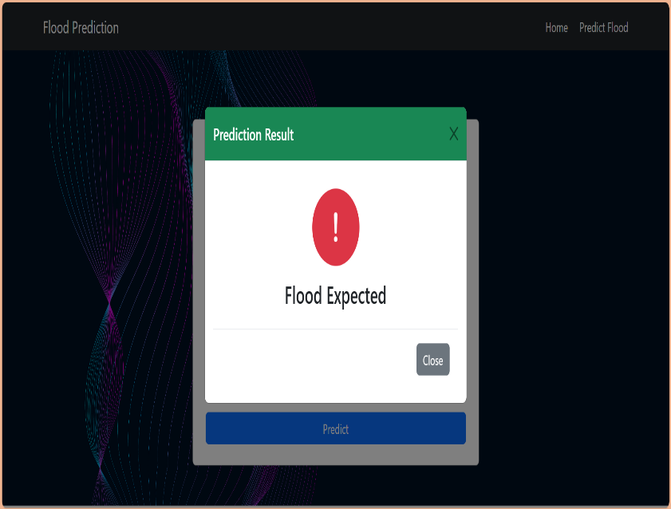
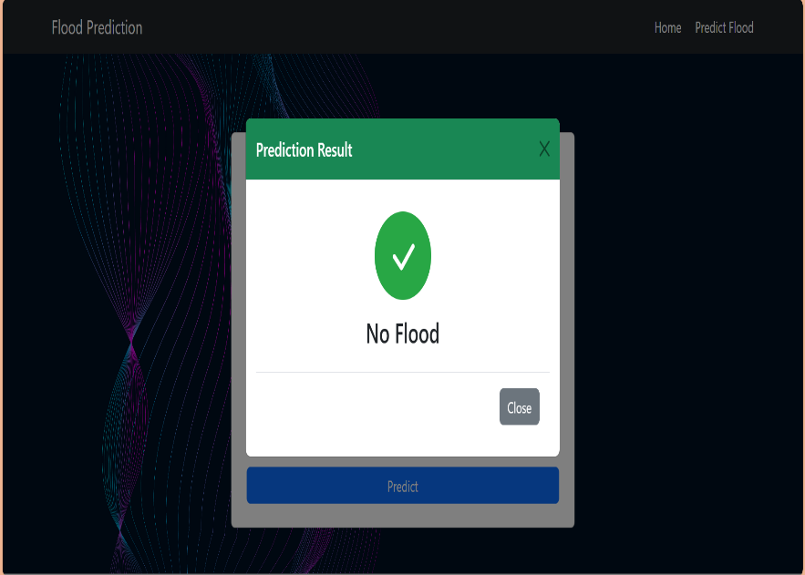
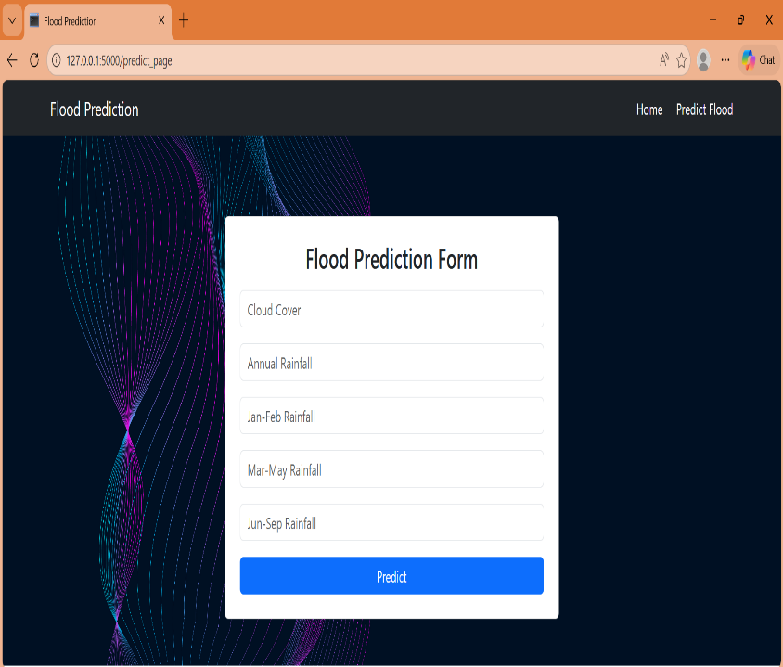
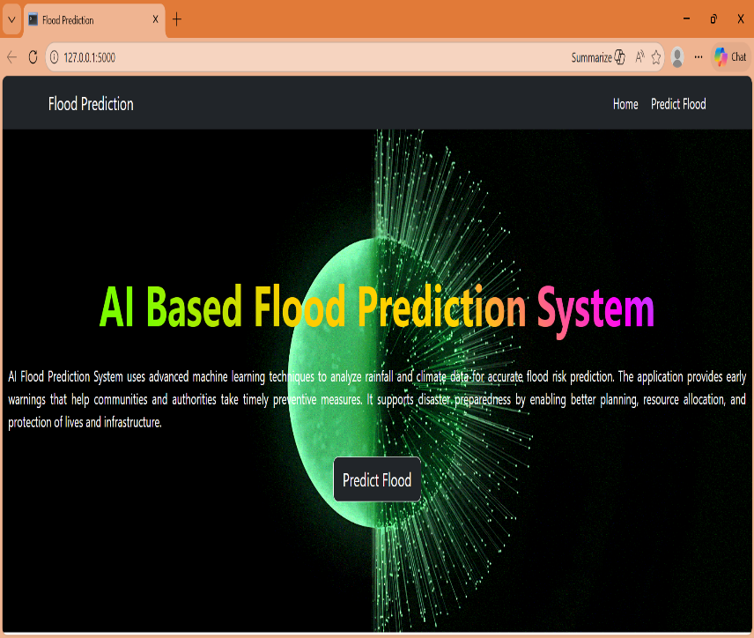

Step-3: Idea Prioritization
After evaluating different solution approaches, we prioritized developing a machine learning–based web application for flood prediction due to its scalability, automation capability, and real-world usability. To implement this solution efficiently, we selected specific technologies and frameworks based on performance and feasibility.
For the machine learning model, we chose XGBoost because of its high accuracy and strong performance in classification problems. For backend development, we selected Flask (Python) as it provides a lightweight and efficient framework to integrate the trained model with a web application. For frontend development, we used HTML, CSS, and Bootstrap to create a responsive and user-friendly interface. Additionally, libraries such as Pandas and NumPy were used for data preprocessing, and Joblib was used for saving and loading the trained model.
These technologies were prioritized because they are reliable, widely used, and suitable for developing a full-stack machine learning application efficiently.

